# Databricks DBUtils Commands

The `dbutils` library in Databricks provides utilities for tasks such as managing files, working with secrets, running notebooks, and managing data flow. Below are the commonly used `dbutils` commands with explanations.

1. Coomand (Code) : dbutils.help()
2. dbutils.secrets.help()

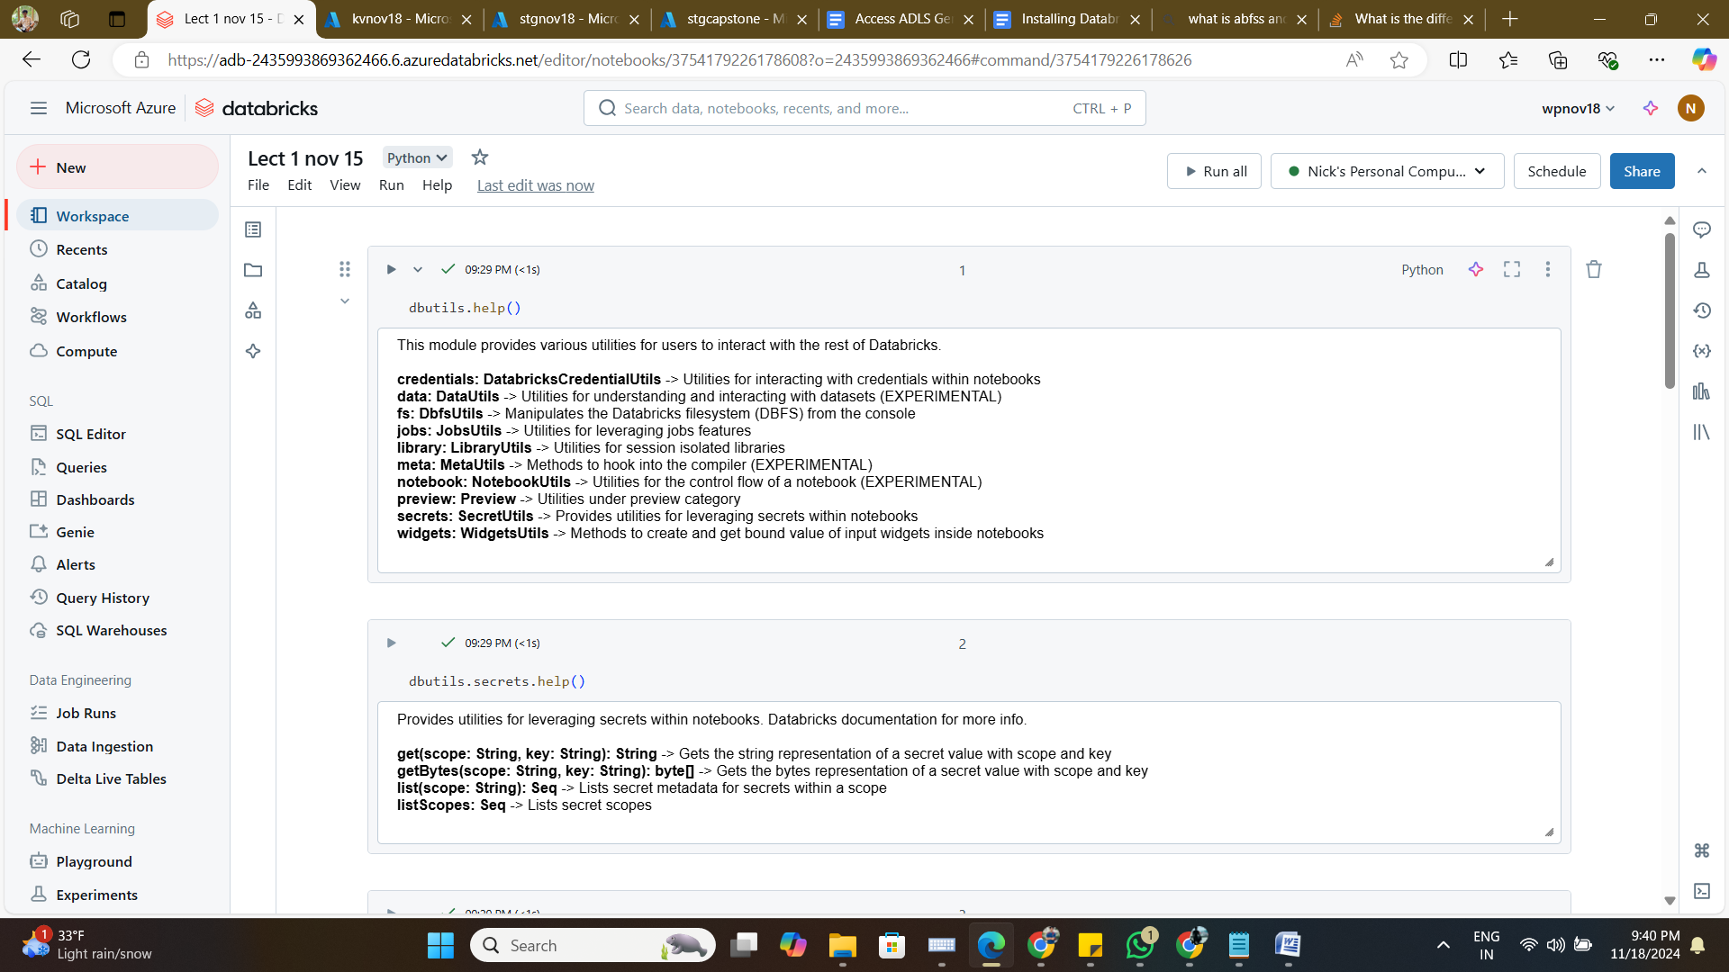

1. dbutils.secrets.listScopes()
2. dbutils.secrets.list('akvconnection')
3. print(dbutils.secrets.get(scope="akvconnection", key=" acckey"))
4. spark.conf.set("fs.azure.account.key.stgnov18.dfs.core.windows.net", dbutils.secrets.get(scope="akvconnection", key="acckey"))

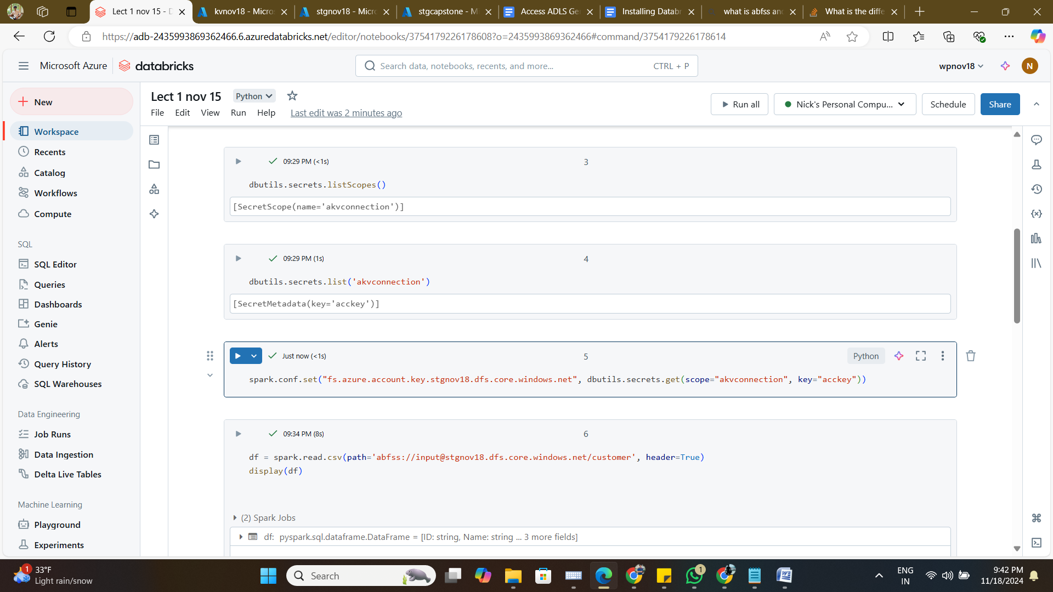

1. df = spark.read.csv(path='abfss://input@stgnov18.dfs.core.windows.net/customer', header=True)

display(df)

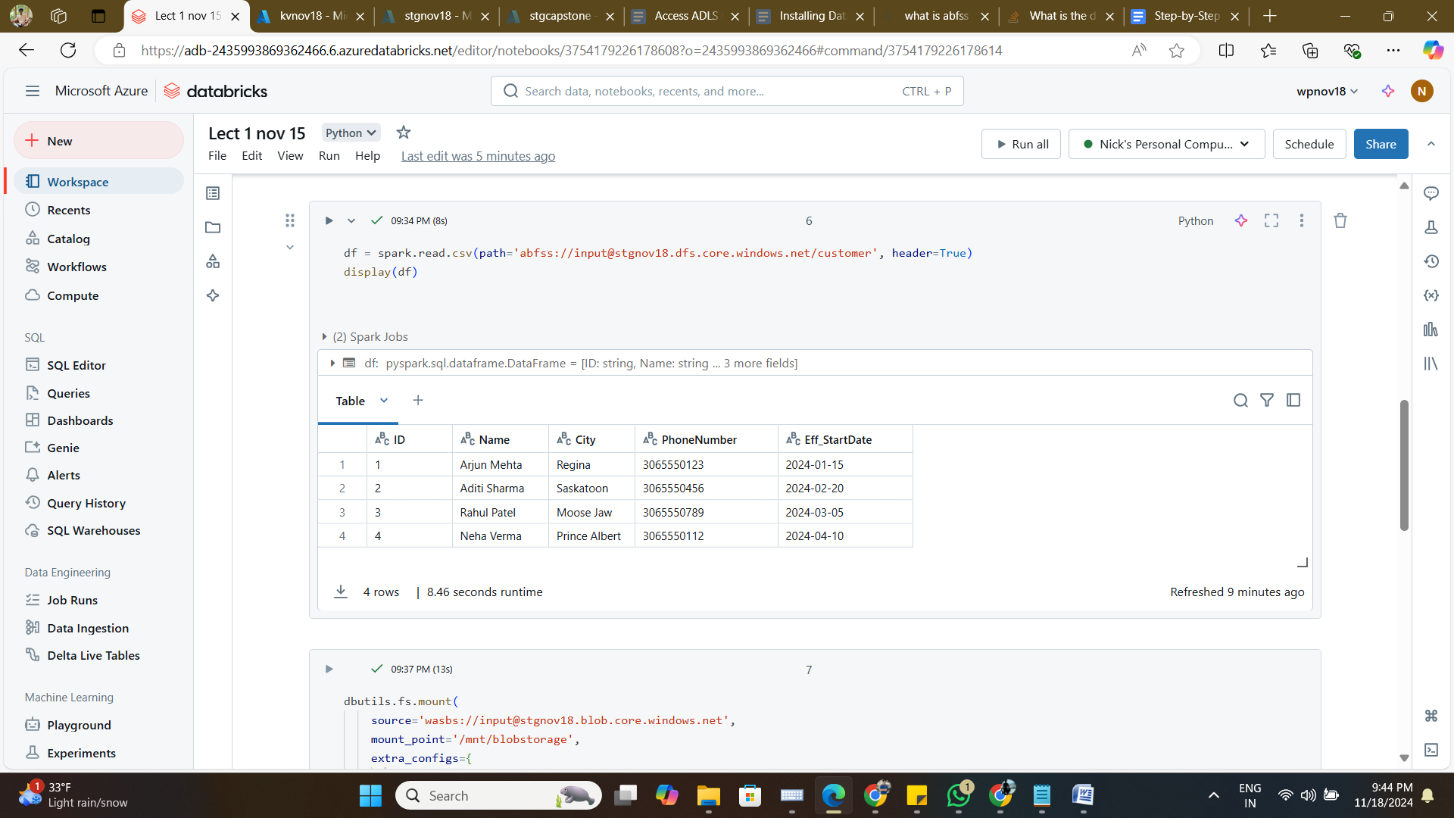

dbutils.fs.mount(

    source='wasbs://input@stgnov18.blob.core.windows.net',

    mount_point='/mnt/blobstorage',

    extra_configs={

        "fs.azure.account.key.stgnov18.blob.core.windows.net": dbutils.secrets.get('akvconnection', 'acckey')

    }

)

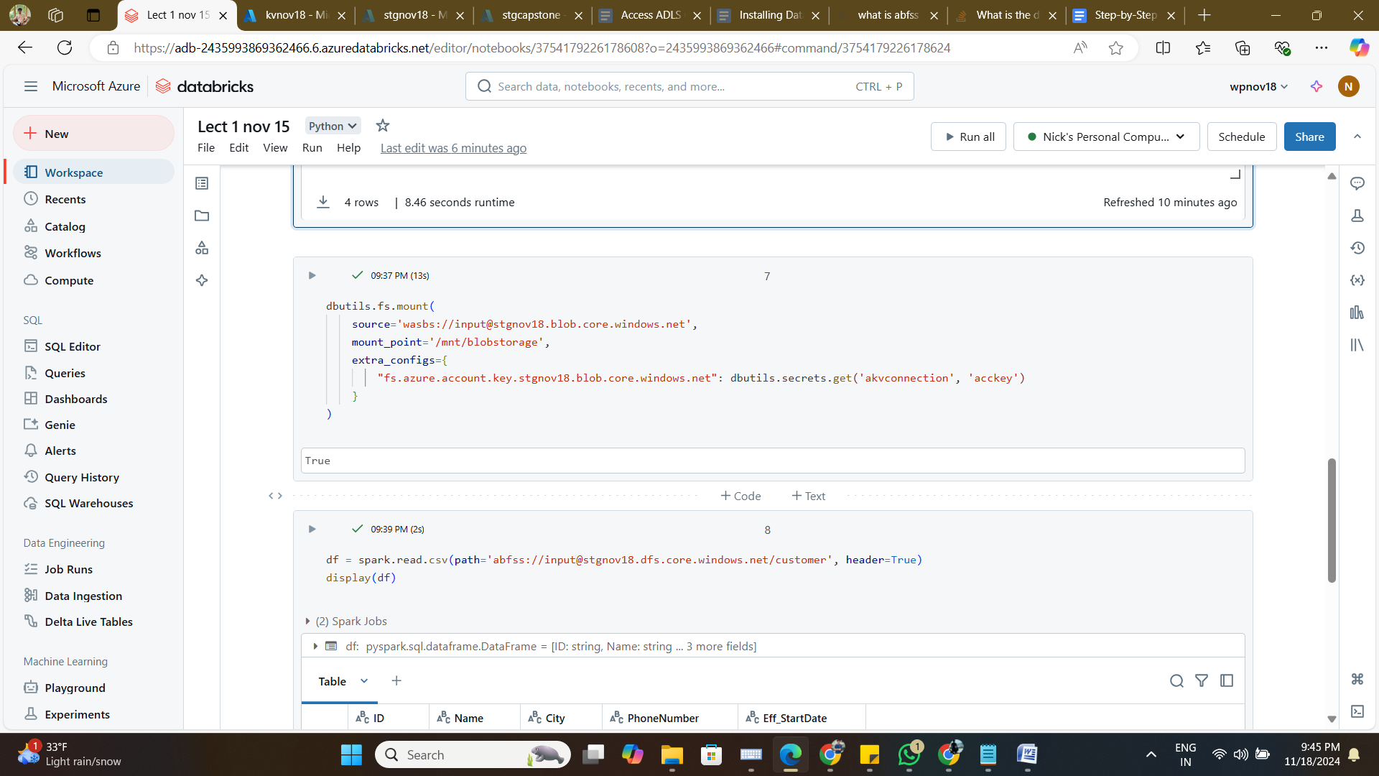

1. df = spark.read.csv(path='abfss://input@stgnov18.dfs.core.windows.net/customer', header=True)

display(df)

